Official project name: Pharmacy Management System
Project sponsor: Pharmacy Owner
Project manager: Nada Khaled
Purpose of the project
The purpose of this project is to develop a Pharmacy Management System that helps pharmacists manage medicines, inventory, suppliers, and sales efficiently. The system aims to reduce human errors, improve inventory control, detect expired medicines, and provide accurate reports.

Business Case
Many pharmacies still rely on manual records, which can lead to errors in medicine sales, stock management, and expiry date tracking. This Pharmacy Management System provides an easy and reliable solution to automate daily pharmacy operations. The system allows pharmacists to manage medicines, monitor stock quantities, record sales, generate reports, and receive notifications for low stock and expired medicines.

Key Deliverables
- Pharmacy Management Desktop Application.
- Medicine Management Module.
- Inventory Management Module.
- Sales Management Module.
- Supplier Management Module.
- Reports Module.
- Database for storing pharmacy information.
- User Manual.

Project Milestones
- Requirements Review: Requirements are complete, approved, and documented.
By: 18/01/2026
- System Design Review: Database design, ERD, DFD, and user interface are completed and approved.
By: 05/02/2026
- Implementation Review: All modules are successfully developed.
By: 26/02/2026
- System Testing: All system functions are tested and verified.
By: 10/03/2026
- Product Operational: The system is ready for deployment and use.
By: 18/03/2026

Project Resources
Staff
- Project Manager – Nada Khaled
- Business/Systems Analyst – Sama Alaa
- Database Designer & Developer – Mariam Abbas
- UI/UX & Application Developer – Sara Ibrahim
- System Tester (QA) – Malak Abu Bakr
- Deployment & Support Coordinator – Basma Refaat
Hardware
- 4 Laptops
- 1 Database Server
Software
- Visual Studio
- SQL Server
- Microsoft Office
- StarUML

Budget
- Estimated project budget is 158,500 L.E

Constraints
- The project must be completed within the allocated budget.
- The project must be completed before 18/03/2026.
- The system will be developed as a desktop application only.
- SQL Server will be used as the database management system.

High Level Risks
- Inaccurate estimation of project schedule.
- Changes in customer requirements.
- Delay in software development.
- Hardware or software failures.
- Loss of project team members.
- Database security issues.
- Customer dissatisfaction with the final product.
- Delay in testing and deployment.
Product Scope Description
The Pharmacy Management System is a desktop application designed to automate the daily activities of a pharmacy. The system enables pharmacists to manage medicines, suppliers, inventory, and sales. It also provides reports, tracks medicine expiry dates, and alerts users when medicine stock is low.

Product Acceptance Criteria
The project will be accepted if:
- The system allows adding, updating, deleting, and searching medicines.
- The system records sales accurately.
- The inventory is automatically updated after each sale.
- The system generates sales and inventory reports.
- The system displays notifications for low stock medicines.
- The system detects expired medicines.
- All data is stored correctly in the database.
- The system works correctly without major errors.

Project Deliverables
- Pharmacy Management System Desktop Application.
- Database Design (ERD).
- Data Flow Diagrams (DFDs).
- Use Case Diagram.
- Database Implementation.
- User Interface Design.
- Project Documentation.
- User Manual.
- Final Project Report.
- Testing Report.

Project Exclusions
The project does not include:
- Online payment services.
- Mobile application.
- Delivery management.
- Integration with hospitals.
- Barcode scanning devices.
- Multi-branch pharmacy management.
- Cloud database services.

Project Constraints
- The project duration is limited to one academic semester.
- The project budget is limited.
- The system will be developed using Visual Studio and SQL Server.
- The application will run on Windows operating systems only.
- The project must be completed before the submission deadline.

Project Assumptions
- The pharmacy provides complete medicine information.
- Users have basic computer skills.
- SQL Server is installed and configured correctly.
- The required hardware is available.
- Internet connection is not required because the system works offline.
- All project team members are available throughout the development period.

Work Breakdown Structure (WBS)
1.0 Pharmacy Management System
1.1 Planning
1.1.1 Collect Project Requirements
1.1.2 Identify Stakeholders
1.1.3 Define Project Scope
1.1.4 Prepare Project Schedule
1.1.5 Prepare Project Budget
1.2 Analysis
1.2.1 Analyze Pharmacy Requirements
1.2.2 Analyze Current Pharmacy Processes
1.2.3 Identify Functional Requirements
1.2.4 Identify Non-Functional Requirements
1.2.5 Identify System Users
1.3 Design
1.3.1 Database Design
1.3.1.1 Design Medicine Table
1.3.1.2 Design Inventory Table
1.3.1.3 Design Sales Table
1.3.1.4 Design Supplier Table
1.3.1.5 Define Database Relationships
1.3.2 User Interface Design
1.3.2.1 Design Login Interface
1.3.2.2 Design Medicine Management Interface
1.3.2.3 Design Inventory Interface
1.3.2.4 Design Sales Interface
1.3.2.5 Design Reports Interface
1.3.3 System Modeling
1.3.3.1 Create Use Case Diagram
1.3.3.2 Create DFD
1.3.3.3 Create ERD
1.4 Development
1.4.1 Medicine Management
1.4.1.1 Add Medicine
1.4.1.2 Update Medicine
1.4.1.3 Delete Medicine
1.4.1.4 Search Medicine
1.4.2 Inventory Management
1.4.2.1 Track Medicine Stock
1.4.2.2 Update Stock After Sale
1.4.2.3 Generate Low Stock Alerts
1.4.2.4 Detect Expired Medicines
1.4.3 Sales Management
1.4.3.1 Record Sales
1.4.3.2 Calculate Sale Total
1.4.3.3 Update Inventory
1.4.3.4 Generate Sales Records
1.4.4 Supplier Management
1.4.4.1 Add Supplier
1.4.4.2 Update Supplier Information
1.4.4.3 Search Supplier
1.4.5 Reports Management
1.4.5.1 Generate Sales Reports
1.4.5.2 Generate Inventory Reports
1.4.5.3 Generate Expired Medicine Reports
1.5 Testing
1.5.1 Test Medicine Management
1.5.2 Test Inventory Management
1.5.3 Test Sales Management
1.5.4 Test Supplier Management
1.5.5 Test Reports
1.5.6 Test Database Operations
1.5.7 Fix Identified Errors
1.5.8 Perform User Acceptance Testing
1.6 Deployment and Closure
1.6.1 Prepare Final System
1.6.2 Install System
1.6.3 Train Pharmacy Staff
1.6.4 Prepare User Manual
1.6.5 Prepare Final Project Report
1.6.6 Final System Delivery

WBS Dictionary
Persons key: N.KH = Nada Khaled | S.AL = Sama Alaa | M.AB = Mariam Abbas | S.IB = Sara Ibrahim | M.AK = Malak Abu Bakr | B.RE = Basma Refaat
Code of accounts number | Description | Persons | No. Resources | Cost | Milestone
1.1 | Planning |  | 7R | 19,000 EGP | 1/1-9/1
1.1.1 | Collect Project Requirements | N.KH | 2R | 6,000 EGP | 1/1-3/1
1.1.2 | Identify Stakeholders | N.KH | 1R | 2,500 EGP | 4/1-4/1
1.1.3 | Define Project Scope | N.KH | 1R | 3,000 EGP | 5/1-6/1
1.1.4 | Prepare Project Schedule | N.KH | 2R | 4,000 EGP | 7/1-8/1
1.1.5 | Prepare Project Budget | N.KH | 1R | 3,500 EGP | 9/1-9/1
1.2 | Analysis |  | 8R | 19,000 EGP | 10/1-18/1
1.2.1 | Analyze Pharmacy Requirements | S.AL | 2R | 5,000 EGP | 10/1-12/1
1.2.2 | Analyze Current Pharmacy Processes | S.AL | 2R | 4,500 EGP | 13/1-14/1
1.2.3 | Identify Functional Requirements | S.AL | 2R | 4,000 EGP | 15/1-16/1
1.2.4 | Identify Non-Functional Requirements | S.AL | 1R | 3,000 EGP | 17/1-17/1
1.2.5 | Identify System Users | S.AL | 1R | 2,500 EGP | 18/1-18/1
1.3 | Design |  | 18R | 33,000 EGP | 19/1-5/2
1.3.1 | Database Design |  | 6R | 11,000 EGP | 19/1-24/1
1.3.1.1 | Design Medicine Table | M.AB | 1R | 2,000 EGP | 19/1-19/1
1.3.1.2 | Design Inventory Table | M.AB | 1R | 2,000 EGP | 20/1-20/1
1.3.1.3 | Design Sales Table | M.AB | 1R | 2,000 EGP | 21/1-21/1
1.3.1.4 | Design Supplier Table | M.AB | 1R | 2,000 EGP | 22/1-22/1
1.3.1.5 | Define Database Relationships | M.AB | 2R | 3,000 EGP | 23/1-24/1
1.3.2 | User Interface Design |  | 6R | 13,000 EGP | 25/1-30/1
1.3.2.1 | Design Login Interface | S.IB | 1R | 2,000 EGP | 25/1-25/1
1.3.2.2 | Design Medicine Management Interface | S.IB | 2R | 3,500 EGP | 26/1-27/1
1.3.2.3 | Design Inventory Interface | S.IB | 1R | 2,500 EGP | 28/1-28/1
1.3.2.4 | Design Sales Interface | S.IB | 1R | 2,500 EGP | 29/1-29/1
1.3.2.5 | Design Reports Interface | S.IB | 1R | 2,500 EGP | 30/1-30/1
1.3.3 | System Modeling |  | 6R | 9,000 EGP | 31/1-5/2
1.3.3.1 | Create Use Case Diagram | S.AL | 2R | 3,000 EGP | 31/1-1/2
1.3.3.2 | Create DFD | S.AL | 2R | 3,000 EGP | 2/2-3/2
1.3.3.3 | Create ERD | M.AB | 2R | 3,000 EGP | 4/2-5/2
1.4 | Development |  | 21R | 44,500 EGP | 6/2-26/2
1.4.1 | Medicine Management |  | 4R | 9,500 EGP | 6/2-9/2
1.4.1.1 | Add Medicine | S.IB | 1R | 2,500 EGP | 6/2-6/2
1.4.1.2 | Update Medicine | S.IB | 1R | 2,500 EGP | 7/2-7/2
1.4.1.3 | Delete Medicine | S.IB | 1R | 2,000 EGP | 8/2-8/2
1.4.1.4 | Search Medicine | S.IB | 1R | 2,500 EGP | 9/2-9/2
1.4.2 | Inventory Management |  | 6R | 11,000 EGP | 10/2-15/2
1.4.2.1 | Track Medicine Stock | M.AB | 2R | 3,000 EGP | 10/2-11/2
1.4.2.2 | Update Stock After Sale | M.AB | 1R | 2,500 EGP | 12/2-12/2
1.4.2.3 | Generate Low Stock Alerts | M.AB | 1R | 2,500 EGP | 13/2-13/2
1.4.2.4 | Detect Expired Medicines | M.AB | 2R | 3,000 EGP | 14/2-15/2
1.4.3 | Sales Management |  | 5R | 10,500 EGP | 16/2-20/2
1.4.3.1 | Record Sales | S.IB | 2R | 3,500 EGP | 16/2-17/2
1.4.3.2 | Calculate Sale Total | S.IB | 1R | 2,000 EGP | 18/2-18/2
1.4.3.3 | Update Inventory | M.AB | 1R | 2,500 EGP | 19/2-19/2
1.4.3.4 | Generate Sales Records | S.IB | 1R | 2,500 EGP | 20/2-20/2
1.4.4 | Supplier Management |  | 3R | 6,000 EGP | 21/2-23/2
1.4.4.1 | Add Supplier | M.AB | 1R | 2,000 EGP | 21/2-21/2
1.4.4.2 | Update Supplier Information | M.AB | 1R | 2,000 EGP | 22/2-22/2
1.4.4.3 | Search Supplier | M.AB | 1R | 2,000 EGP | 23/2-23/2
1.4.5 | Reports Management |  | 3R | 7,500 EGP | 24/2-26/2
1.4.5.1 | Generate Sales Reports | S.IB | 1R | 2,500 EGP | 24/2-24/2
1.4.5.2 | Generate Inventory Reports | S.IB | 1R | 2,500 EGP | 25/2-25/2
1.4.5.3 | Generate Expired Medicine Reports | S.IB | 1R | 2,500 EGP | 26/2-26/2
1.5 | Testing |  | 12R | 24,000 EGP | 27/2-10/3
1.5.1 | Test Medicine Management | M.AK | 1R | 2,500 EGP | 27/2-27/2
1.5.2 | Test Inventory Management | M.AK | 1R | 2,500 EGP | 28/2-28/2
1.5.3 | Test Sales Management | M.AK | 1R | 2,500 EGP | 1/3-1/3
1.5.4 | Test Supplier Management | M.AK | 1R | 2,000 EGP | 2/3-2/3
1.5.5 | Test Reports | M.AK | 1R | 2,000 EGP | 3/3-3/3
1.5.6 | Test Database Operations | M.AB & M.AK | 2R | 3,500 EGP | 4/3-5/3
1.5.7 | Fix Identified Errors | M.AB, S.IB & M.AK | 3R | 5,000 EGP | 6/3-8/3
1.5.8 | Perform User Acceptance Testing | N.KH & M.AK | 2R | 4,000 EGP | 9/3-10/3
1.6 | Deployment and Closure |  | 10R | 19,000 EGP | 11/3-18/3
1.6.1 | Prepare Final System | N.KH & S.IB | 2R | 4,000 EGP | 11/3-12/3
1.6.2 | Install System | N.KH & B.RE | 2R | 4,000 EGP | 13/3-13/3
1.6.3 | Train Pharmacy Staff | N.KH & S.AL | 2R | 3,500 EGP | 14/3-15/3
1.6.4 | Prepare User Manual | N.KH & S.AL | 2R | 3,000 EGP | 16/3-16/3
1.6.5 | Prepare Final Project Report | N.KH | 1R | 2,500 EGP | 17/3-17/3
1.6.6 | Final System Delivery | N.KH & S.IB | 1R | 2,000 EGP | 18/3-18/3

Responsibility Matrix
Task | Nada Khaled | Sama Alaa | Mariam Abbas | Sara Ibrahim | Malak Abu Bakr | Basma Refaat
Collect Project Requirements | R | S | S | S | S | S
Identify Stakeholders | R | S | S | S | S | S
Define Project Scope | R | S | S | S | S | S
Prepare Project Schedule | R | S | S | S | S | S
Prepare Project Budget | R | S | S | S | S | S
Analyze Pharmacy Requirements | S | R | S | S | S | S
Analyze Current Pharmacy Processes | S | R | S | S | S | S
Identify Functional Requirements | S | R | S | S | S | S
Identify Non-Functional Requirements | S | R | S | S | S | S
Identify System Users | S | R | S | S | S | S
Design Medicine Table | S | S | R | S | S | S
Design Inventory Table | S | S | R | S | S | S
Design Sales Table | S | S | R | S | S | S
Design Supplier Table | S | S | R | S | S | S
Define Database Relationships | S | S | R | S | S | S
Design Login Interface | S | S | S | R | S | S
Design Medicine Management Interface | S | S | S | R | S | S
Design Inventory Interface | S | S | S | R | S | S
Design Sales Interface | S | S | S | R | S | S
Design Reports Interface | S | S | S | R | S | S
Create Use Case Diagram | S | R | S | S | S | S
Create DFD | S | R | S | S | S | S
Create ERD | S | S | R | S | S | S
Add Medicine | S | S | S | R | S | S
Update Medicine | S | S | S | R | S | S
Delete Medicine | S | S | S | R | S | S
Search Medicine | S | S | S | R | S | S
Track Medicine Stock | S | S | R | S | S | S
Update Stock After Sale | S | S | R | S | S | S
Generate Low Stock Alerts | S | S | R | S | S | S
Detect Expired Medicines | S | S | R | S | S | S
Record Sales | S | S | S | R | S | S
Calculate Sale Total | S | S | S | R | S | S
Update Inventory | S | S | R | S | S | S
Generate Sales Records | S | S | S | R | S | S
Add Supplier | S | S | R | S | S | S
Update Supplier Information | S | S | R | S | S | S
Search Supplier | S | S | R | S | S | S
Generate Sales Reports | S | S | S | R | S | S
Generate Inventory Reports | S | S | S | R | S | S
Generate Expired Medicine Reports | S | S | S | R | S | S
Test Medicine Management | S | S | S | S | R | S
Test Inventory Management | S | S | S | S | R | S
Test Sales Management | S | S | S | S | R | S
Test Supplier Management | S | S | S | S | R | S
Test Reports | S | S | S | S | R | S
Test Database Operations | S | S | R | S | R | S
Fix Identified Errors | S | S | R | R | R | S
Perform User Acceptance Testing | R | S | S | S | R | S
Prepare Final System | R | S | S | R | S | S
Install System | R | S | S | S | S | R
Train Pharmacy Staff | R | R | S | S | S | S
Prepare User Manual | R | R | S | S | S | S
Prepare Final Project Report | R | S | S | S | S | S
Final System Delivery | R | S | S | R | S | S

Communication Plan
Information | Audience | When? | Communication Method | Preparer
Project Requirements | Project Team & Pharmacy Owner | At the beginning of the project | Meeting | Sama Alaa
Project Scope | Project Team & Pharmacy Owner | At the beginning of the project | Meeting & E-mail | Nada Khaled
Project Schedule | Project Team | At the beginning and when updated | Meeting & E-mail | Nada Khaled
Project Budget | Project Team | At the beginning and when updated | E-mail & Meeting | Basma Refaat
Project Progress Report | Project Team | Weekly | Meeting & E-mail | Nada Khaled
System Analysis Results | Project Team & Pharmacy Owner | After completing analysis | Meeting & Report | Sama Alaa
System Design | Project Team & Pharmacy Owner | After completing design | Meeting & Presentation | Mariam Abbas
Database Design | Project Team | During the design phase | Meeting & E-mail | Mariam Abbas
Development Progress | Project Team | Weekly during development | Meeting & E-mail | Sara Ibrahim
Testing Plan | Project Team | Before testing starts | Meeting & E-mail | Malak Abu Bakr
Testing Results | Project Team & Pharmacy Owner | After testing | Report & Meeting | Malak Abu Bakr
Problems and Issues | Project Team | Whenever an issue occurs | Meeting & Team Group | All Team Members
Project Changes | Project Team & Pharmacy Owner | When a change is required | Meeting & E-mail | Nada Khaled
Customer Feedback | Project Team | When required | Meeting & E-mail | Nada Khaled
Project Milestone Status | Project Team & Pharmacy Owner | At each milestone | Report & Meeting | Nada Khaled
User Training Information | Pharmacy Staff | Before system delivery | Training Session | Sama Alaa
Final Project Report | Project Team & Pharmacy Owner | At project completion | Report & Presentation | Nada Khaled
Final System Delivery | Pharmacy Owner & Project Team | At project completion | Presentation & Meeting | Nada Khaled

Network

ID | Task Name | Duration | Predecessors | Resources
1 | 1.1 Planning | 9 days | - | 7
2 | 1.2 Analysis | 9 days | 1 | 8
3 | 1.3 Design | 18 days | 2 | 18
4 | 1.4 Development | 21 days | 3 | 21
5 | 1.5 Testing | 12 days | 4 | 12
6 | 1.6 Deployment and Closure | 8 days | 5 | 10

Network Diagram:

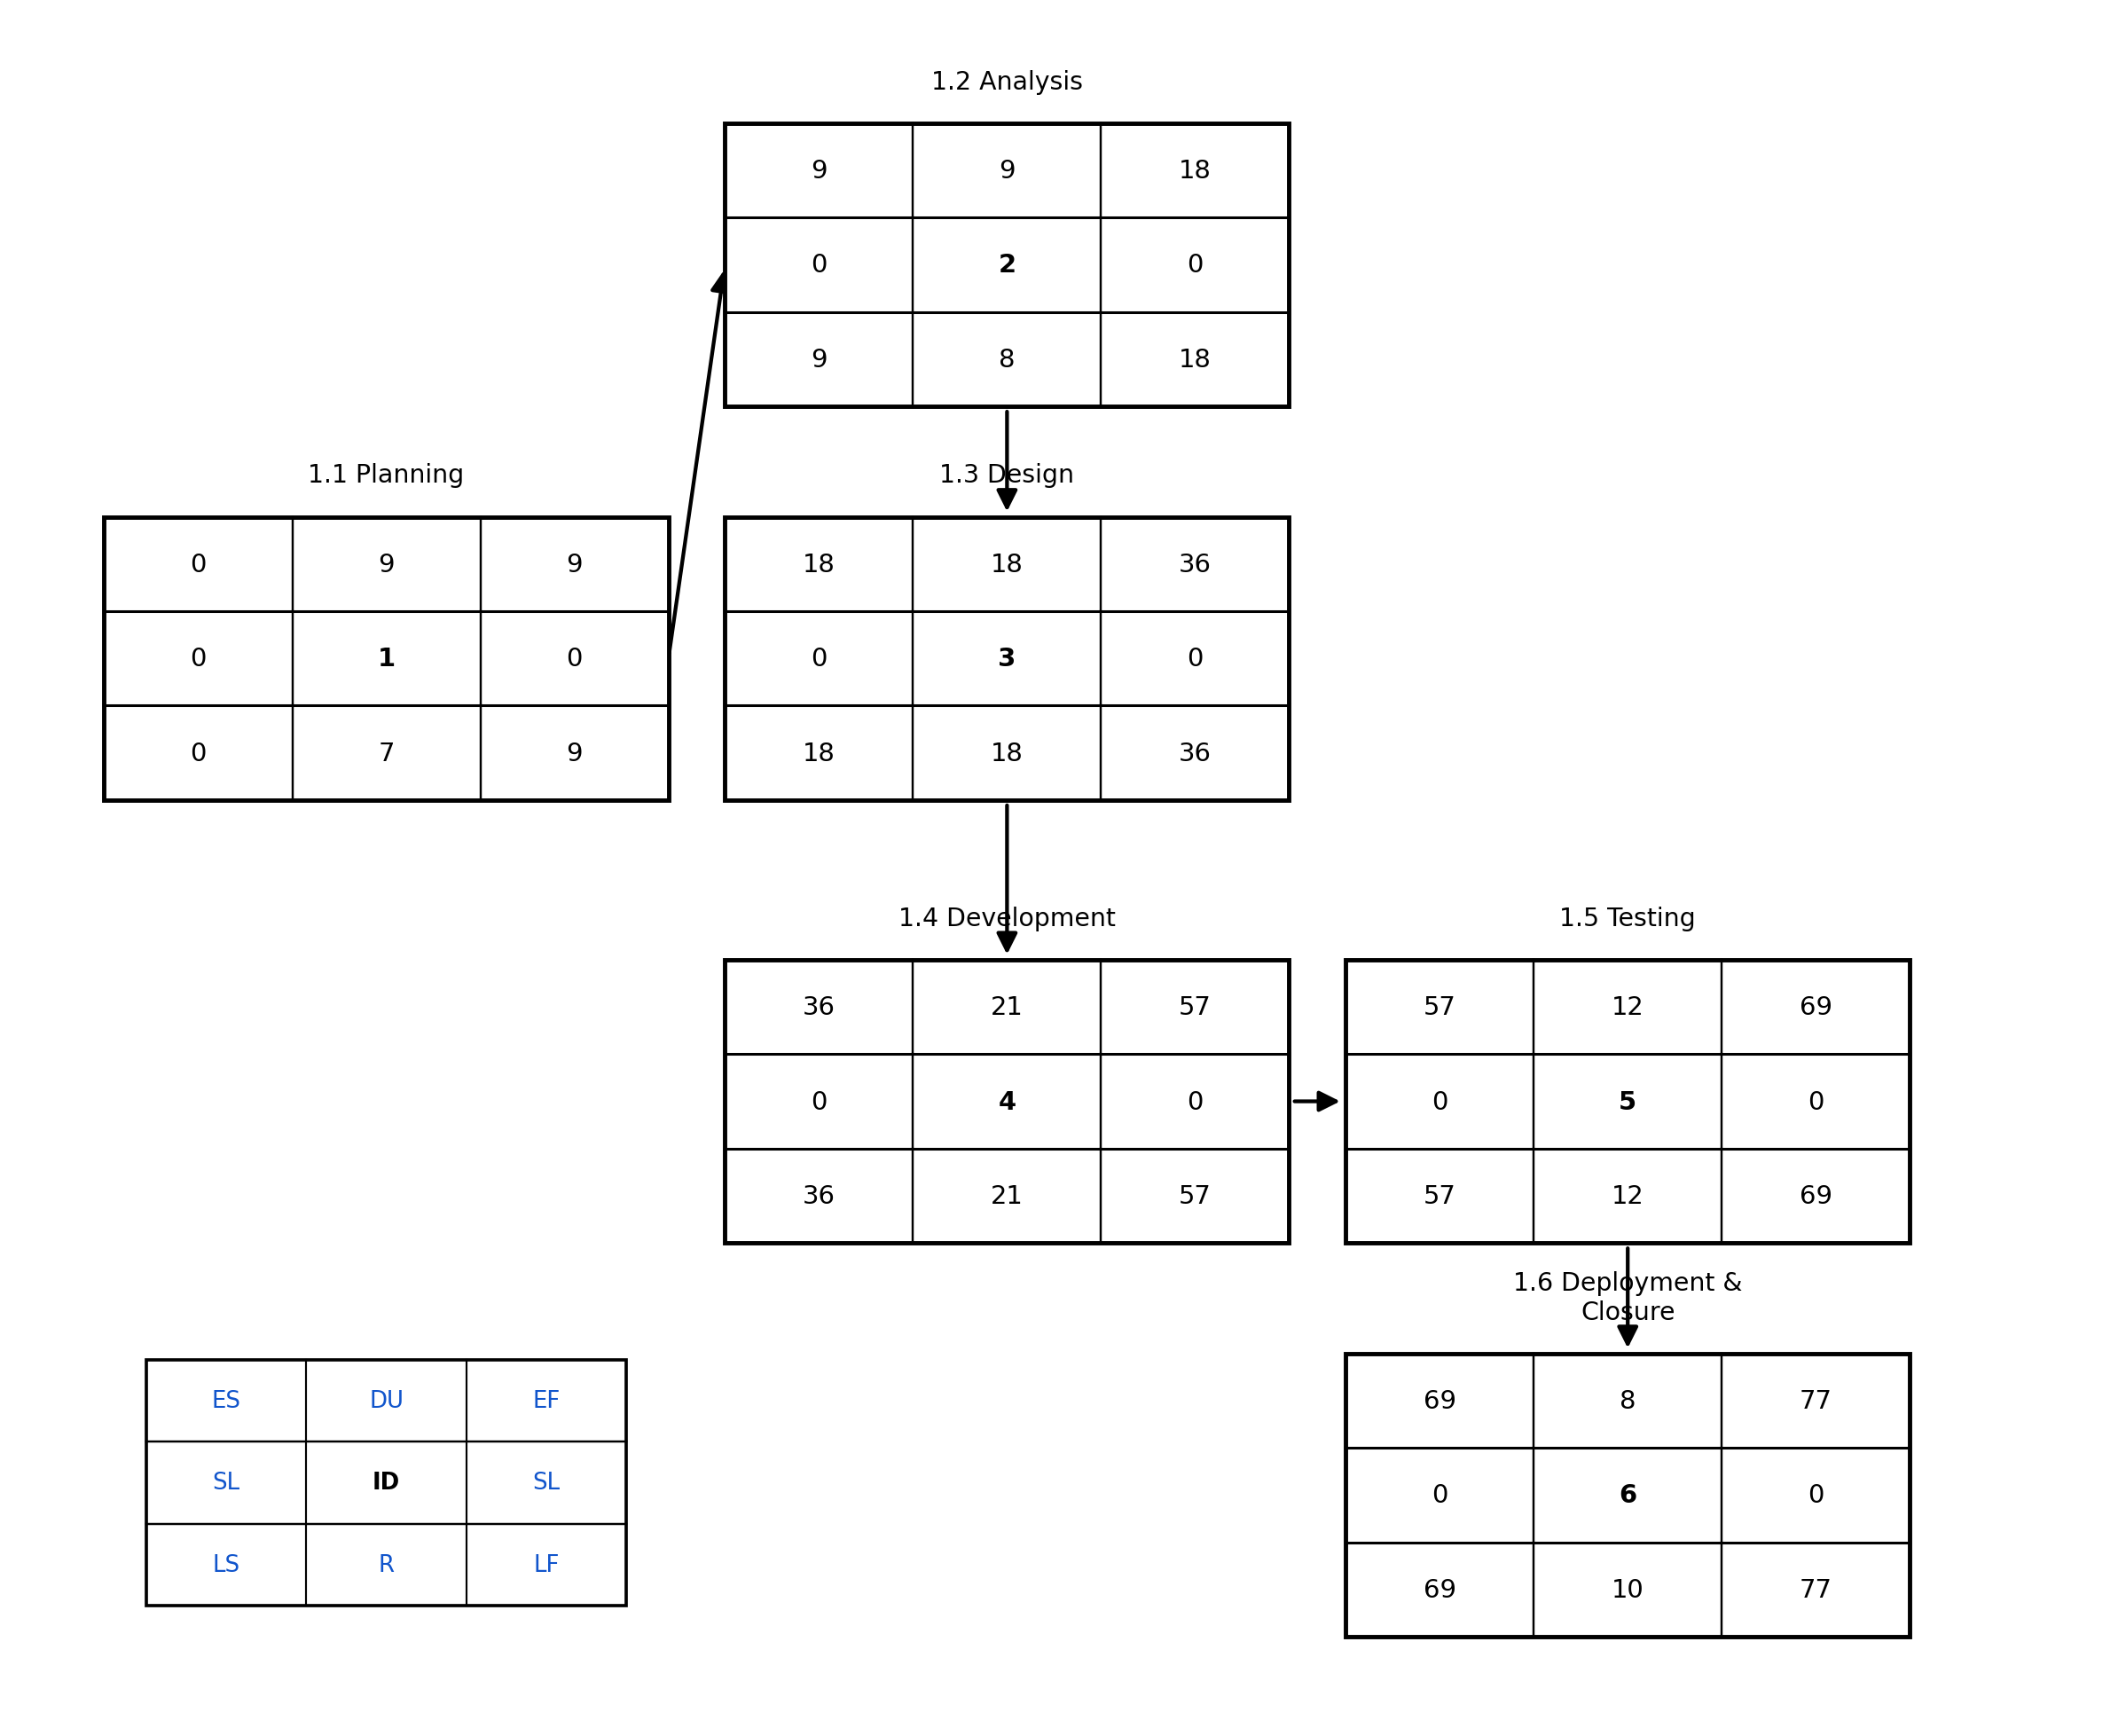

Critical Path: 1.1 Planning → 1.2 Analysis → 1.3 Design → 1.4 Development → 1.5 Testing → 1.6 Deployment and Closure (Total Duration = 77 days, Total Slack = 0 on every activity).

Resource Allocation

ID | Task Name | R | Du | ES | LF | SL | W1 | W2 | W3 | W4 | W5 | W6 | W7 | W8 | W9 | W10 | W11
1 | 1.1 Planning | 7 | 9 | 0 | 9 | 0 | 7 | 7
2 | 1.2 Analysis | 8 | 9 | 9 | 18 | 0 |  | 8 | 8
3 | 1.3 Design | 18 | 18 | 18 | 36 | 0 |  |  | 18 | 18 | 18 | 18
4 | 1.4 Development | 21 | 21 | 36 | 57 | 0 |  |  |  |  |  | 21 | 21 | 21 | 21
5 | 1.5 Testing | 12 | 12 | 57 | 69 | 0 |  |  |  |  |  |  |  |  | 12 | 12
6 | 1.6 Deployment and Closure | 10 | 8 | 69 | 77 | 0 |  |  |  |  |  |  |  |  |  | 10 | 10

Resource usage stays within the available team capacity throughout the schedule (no activity requires more resources than the team members assigned to it, and phases run one after another with zero overlap), so no resource leveling/shifting was required.

Time Phase Budget

ID | Task Name | Effort  (weeks) | Total  Budget | W1 | W2 | W3 | W4 | W5 | W6 | W7 | W8 | W9 | W10 | W11
1 | 1.1 Planning | 2 | 19,000 EGP | 9,000 | 10,000 | - | - | - | - | - | - | - | - | -
2 | 1.2 Analysis | 2 | 19,000 EGP | - | 9,000 | 10,000 | - | - | - | - | - | - | - | -
3 | 1.3 Design | 4 | 33,000 EGP | - | - | 7,000 | 9,500 | 9,500 | 7,000 | - | - | - | - | -
4 | 1.4 Development | 4 | 44,500 EGP | - | - | - | - | - | 9,500 | 13,000 | 13,000 | 9,000 | - | -
5 | 1.5 Testing | 2 | 24,000 EGP | - | - | - | - | - | - | - | - | 11,500 | 12,500 | -
6 | 1.6 Deployment and Closure | 2 | 19,000 EGP | - | - | - | - | - | - | - | - | - | 9,000 | 10,000
 | WEEKLY TOTAL |  | 158,500 EGP | 9,000 | 19,000 | 17,000 | 9,500 | 9,500 | 16,500 | 13,000 | 13,000 | 20,500 | 21,500 | 10,000
 | CUMULATIVE |  |  | 9,000 | 28,000 | 45,000 | 54,500 | 64,000 | 80,500 | 93,500 | 106,500 | 127,000 | 148,500 | 158,500

The budget follows the project's work intensity rather than a flat split: costs are lower while a phase is ramping up or winding down, and peak during its busiest week(s) - e.g. Development (44,500 EGP) peaks at 13,000 EGP/week in weeks 7-8 when coding effort is highest. Spending is only triggered in the weeks a phase is actually active, so the cumulative curve matches the Gantt schedule.

